A000-Indo-Borneo-Hudoq Mask-ca 1900

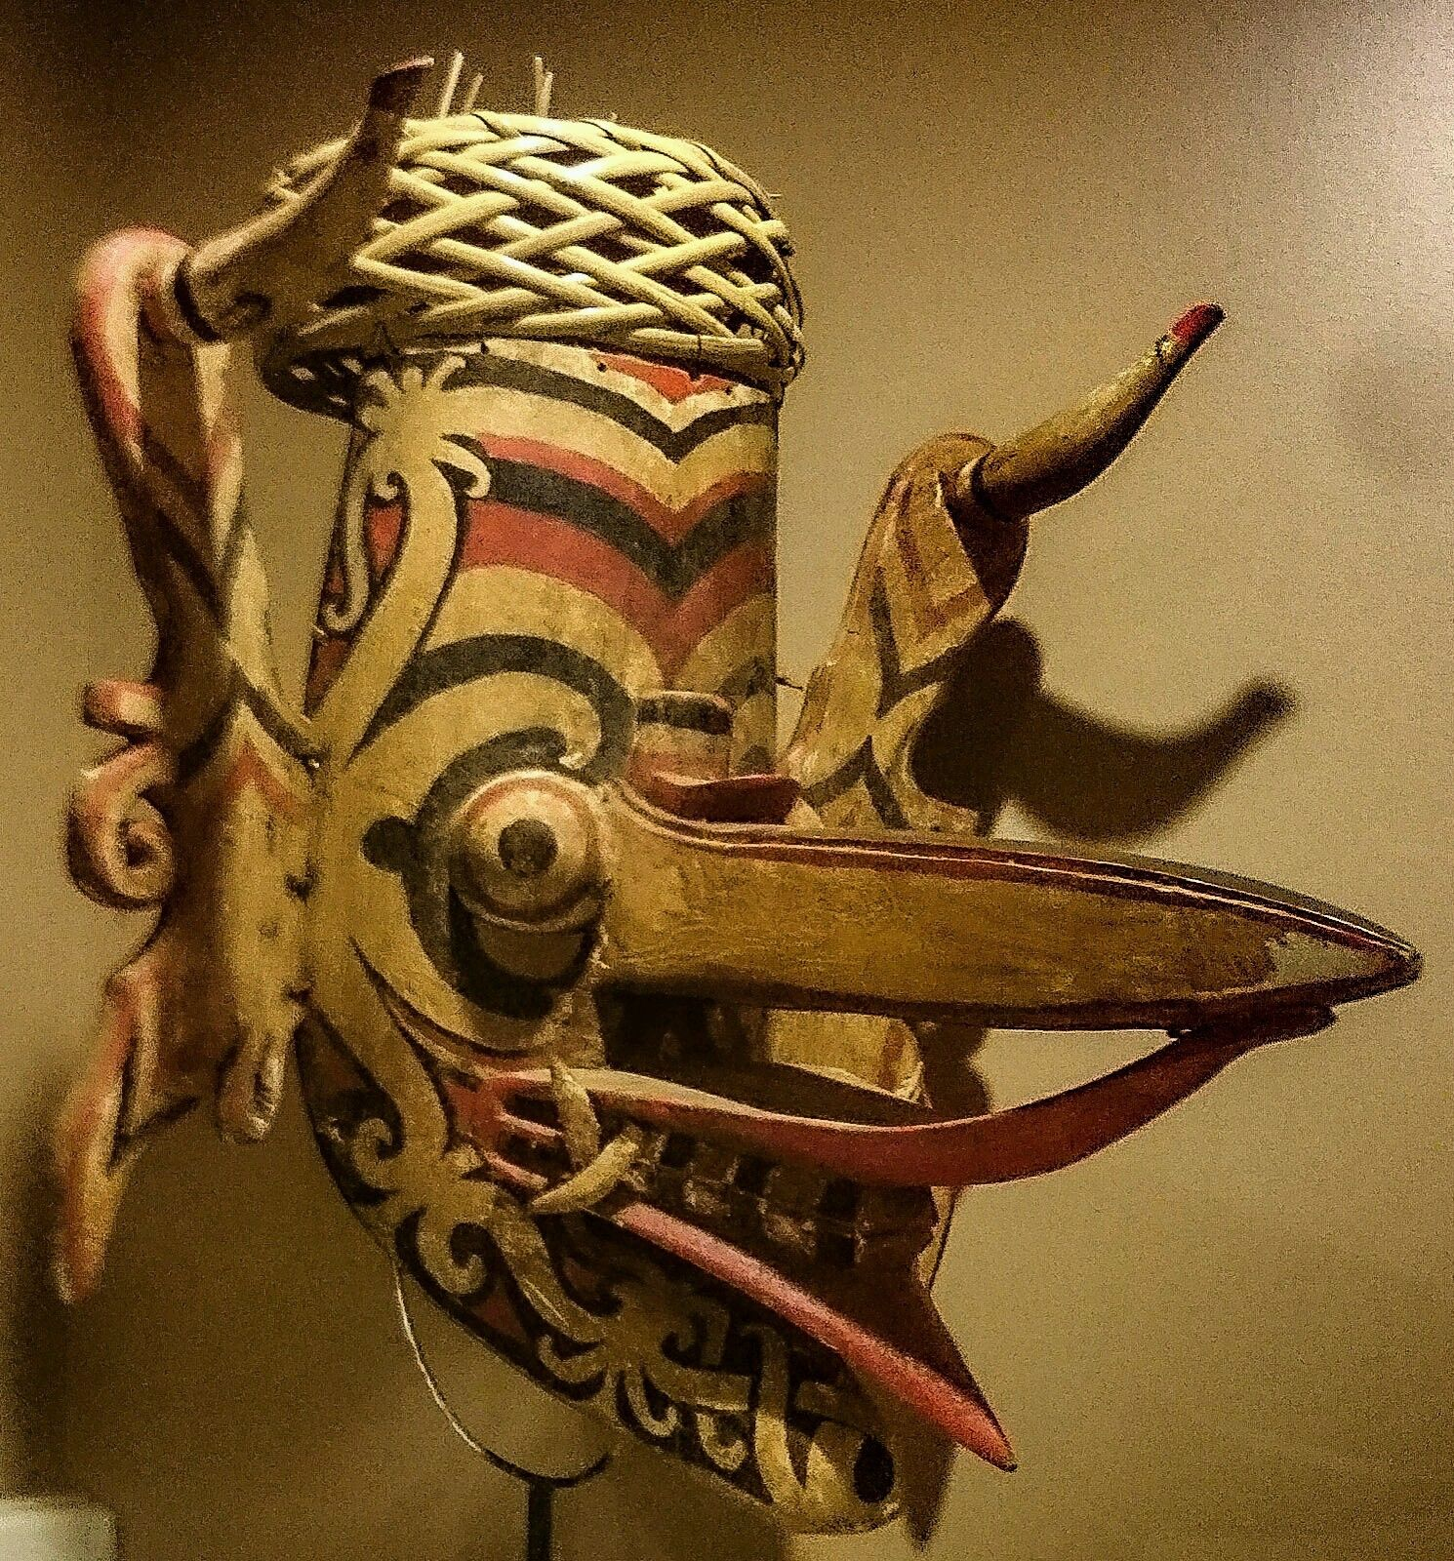 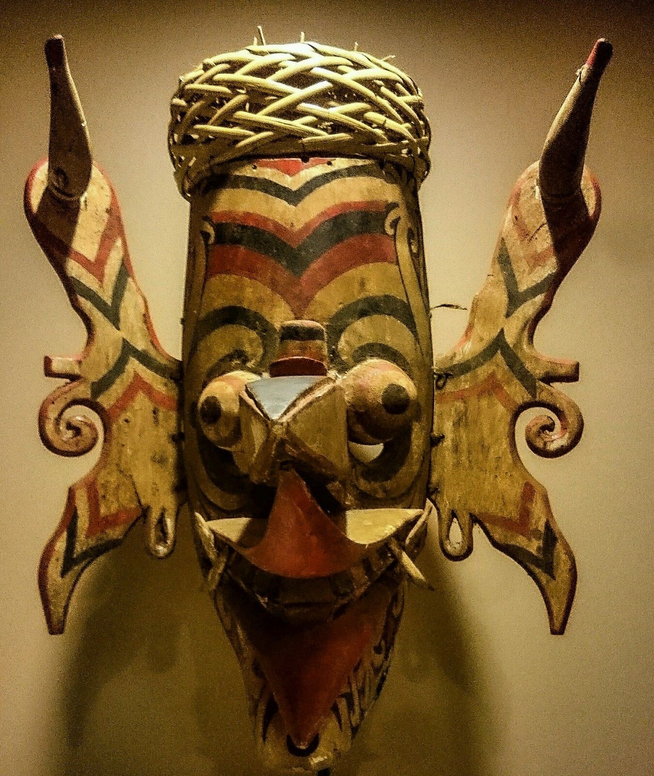 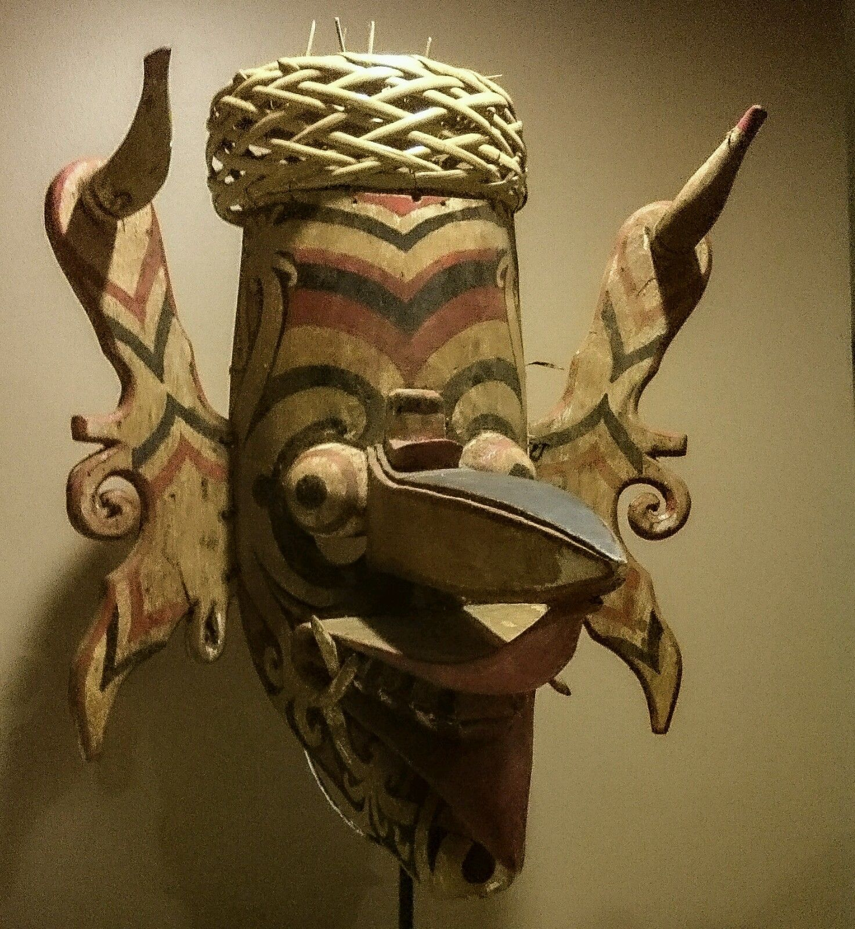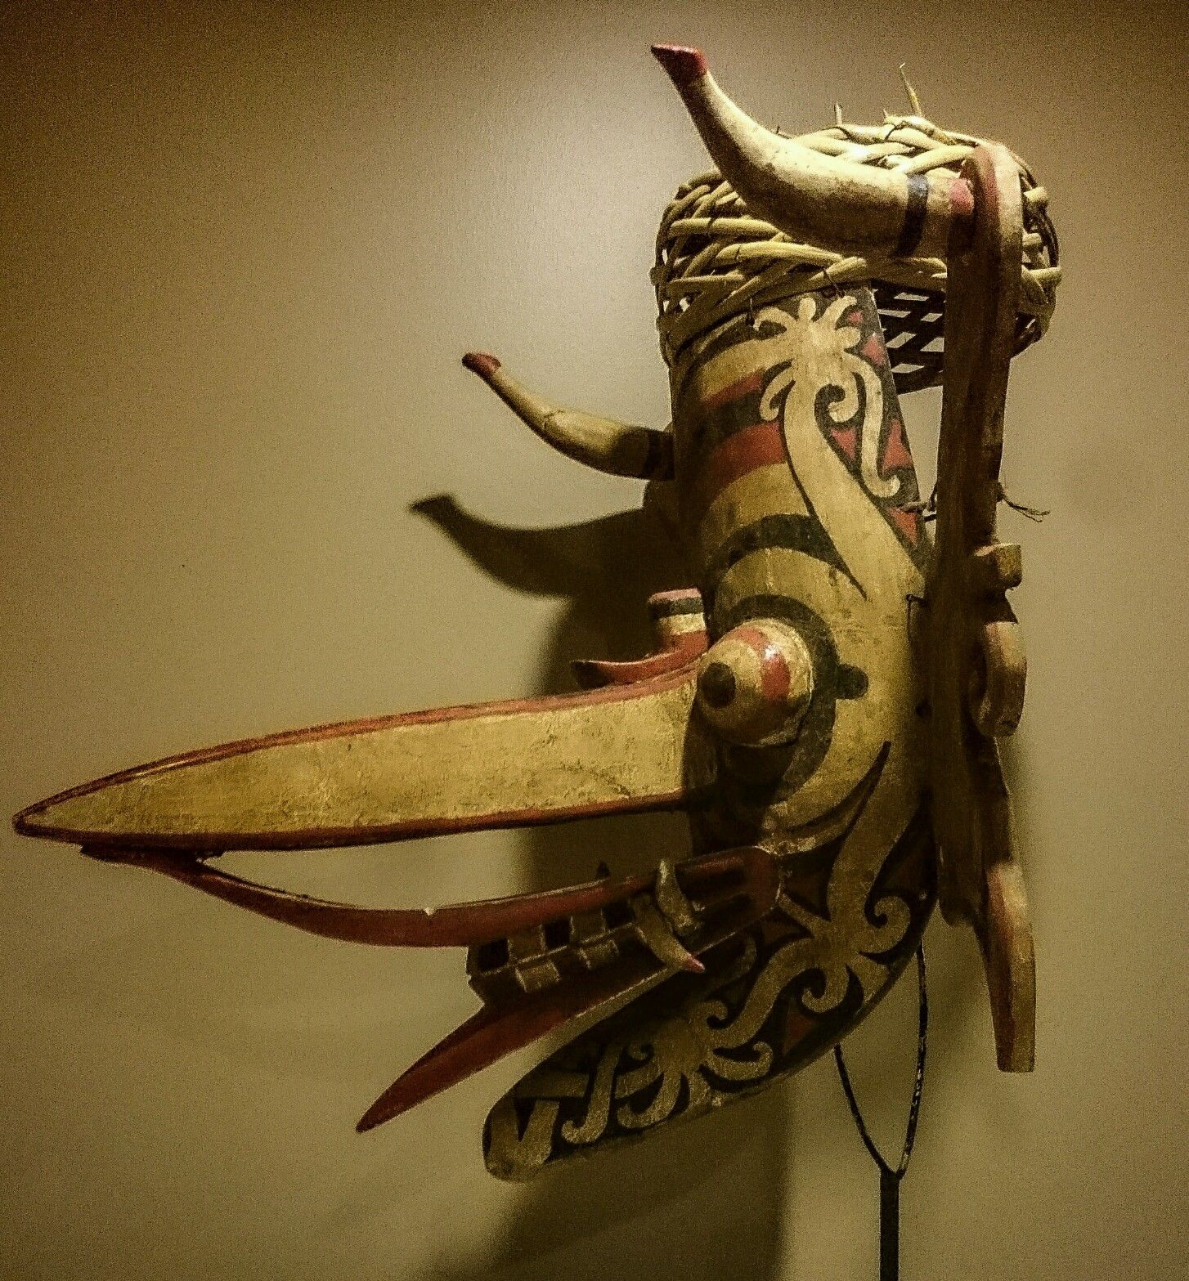

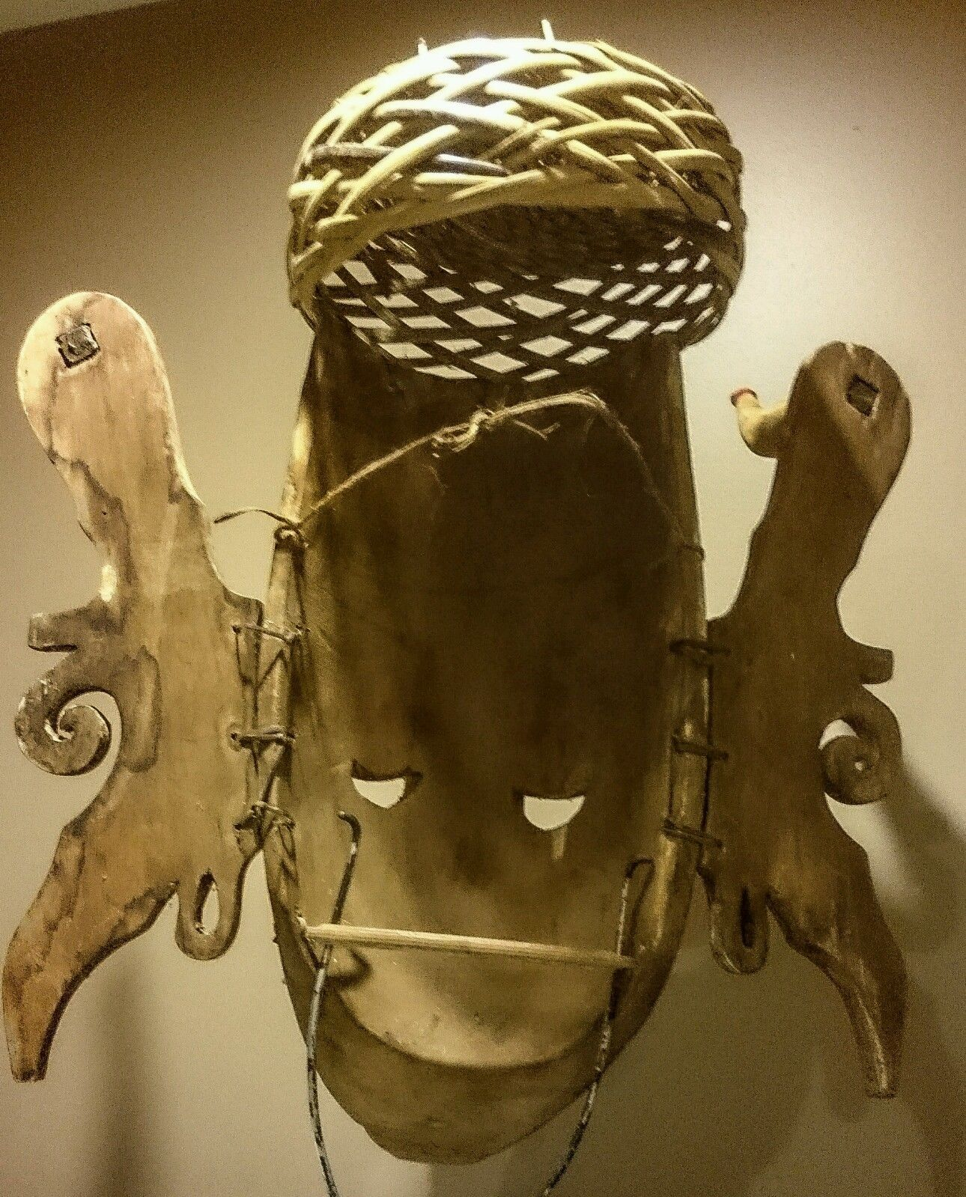 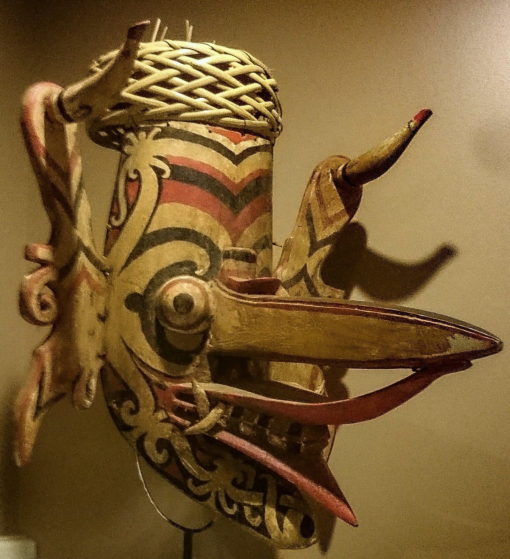

Figs. 1-6. Borneo-Hudoq Mask-ca 1900

Case no.: Oceania

Accession Number:

Formal Label: Borneo-Hudoq Mask-ca 1900

**Display Description:**

This mask is from the Bahau people, a Dayak sub-group, that lives in the Mahakam River region of Borneo. It is of light wood and represents a composite dragon-hornbill spirit. It would have been worn by a dancer at planting, harvest and similar festivals. Young male dancers wearing such masks and cloaks would enter the village at important times connected with the rice growing cycle and would impersonate the spirits who have come down to earth to bless the   
harvest, a ritual known as the *hudoq*. Apertures just below the mask's 'eyes' allowed the dancer to see.  
  
This mask comprises the central head element, ears attached by means of rattan ties, a woven rattan basket cap, and two strings of pendant beads that hang from the ear lobes of the mask. The mask is painted in cream, red and black polychrome. The beads are of glass and are trade beads.  
  
The mask has a protruding mouth from which two sets of fangs project. The ears are embellished with two sets of protruding ear ornaments. The eyes are black, semi-spherical and bulging. And the prominent beak juts out almost horizontally.  
Exuberantly designed and finely executed with dimensional carvings of pronounced jaws, pointed fangs, prominent snout and ears, painted in trade paints of red, off white and black with a sort of stubby tendril motif, significant to the Bahau Dayaks. Used during festivals to reunite the rice spirits with the growing of rice - they are associated with good spirits, protectors of the earth, who ensure fertility and prosperity for the village. This mask would be worn with a skin or rattan hat inserted with the tail feathers of the hornbill (not present here).  
The mask was worn by fitting the basket cap over the dancer's head allowing the mask to hang down over the dancer's face.

This beautiful hudoq mask from the dayak people of borneo is well made and unlike many other hudoq masks as above the nose has a toucan carved into it. This is a genuine used mask so it does have some signs of small damage but that's to be expected. It has a mouth bar in the back to keep it in place. Originally there would have been a weaved hat on the top with toucan feathers but the exportation if these items is forbidden. This mask has a thick patina. Hudoq is a thanksgiving festival of many of sub-groups of the Dayak ethnic group of East Kalimantan province, Indonesia.   
According to the traditional beliefs of the Bahau, Busang, Modang, Ao’heng, and Penihing people, hudoqs are thirteen crop-destroying pests, including rats, lions, and crows. In the festival the Hudoqs are symbolized by dancers who wear masks representing pests and jackets made of areca palm or banana tree bark. The dance is finished when two human hudoqs come out and chase the pest hudoqs. The dance duration is 1–5 hours. It is arranged from village to village after people dibble the land to grow dry-field rice paddies in September to October every year. They pray so that their fields will grow abundantly.

**LC Classification:** DS646.32.D9

Date or Time Horizon: c 1900-1950

Geographical Area: Borneo

**Map:**

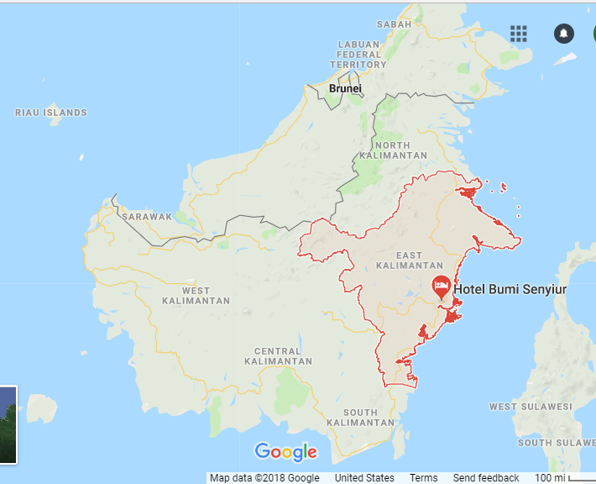

**GPS coordinates:**

Cultural Affiliation:

Media: plai wood and heart wood, pigments

Dimensions:

Weight:

Condition: original danced mask

Provenance: ca 1950 Sold by [**wandererswonders**](http://myworld.ebay.com/wandererswonders) ( [262](http://feedback.ebay.com/ws/eBayISAPI.dll?ViewFeedback&userid=wandererswonders) )

**Discussion:**

Hudoq Dance  
Dayak Bahau people express the god face with Hudoq mask made of plai wood or heart wood. Silau Apau Legaan who has a little of Buang Atut Uhut Mebang that lives in Apau Lagaan, the highest ruler among many kind of Hudoq.  
This greatest ruler delegates the good gods to the earth to save humans and purifies the world from defilement caused by crimes.

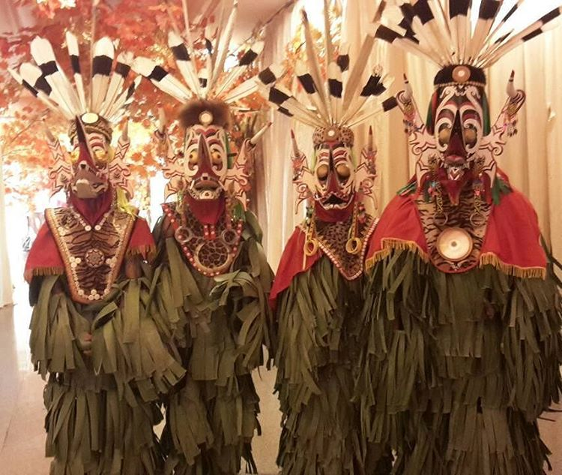

Dancers using this mask in live performances. Courtesy [**wandererswonders**](http://myworld.ebay.com/wandererswonders)

The arrive at the same time as the farmers planting the rice because it represents the peaceful life and well-being.  
The gods that were sent to the earth to bring easy prosperity, the rice plant crops over flown, also to kill the diseases of people, animals or rice that has just been planted, pass over the boundary guard named Jelifah Tao Hudoq who will then change their faces, chlothes and shapes of their body. If they don’t change their face, the people who live in the earth will get bad luck.(vb/yuliawan andrianto)

Related examples are illustrated in Barbier (1984, p. 80), Maxwell (2010, p. 89), Hardianti & ter Keurs (2005, p. 99), Miksic (2007, p. 226), Capistrano-Baker   
(1994, p. 32), and Meulenbeld *et al* (1988, p. 125).  
  
Masks in museum collections often no longer retain their woven rattan caps.  
  
The example here is in an excellent, stable condition with no losses or repairs. It has a patina consistent with an early twentieth century dating.

**References:**

Barbier, J.P. 1984.*Indonesian Primitive Art.* Dallas:Dallas Museum of Art.  
Capistrano-Baker, F.H. 1994. *Art of Island Southeast Asia: The Fred and Rita Richman Collection in the Metropolitan Museum of Art*. New York: The Metropolitan Museum of Art.  
Hardianti, E.S. & P. ter Keurs, eds. 2005. *Indonesia: The Discovery of the Past*, KIT Publishers for De Nieuwe Kerk, Amsterdam.  
Maxwell, R. 2010. *Life, Death & Magic: 2000 Years of Southeast Asian Ancestral Art* Sydney: National Gallery of Australia, 2010.  
Meulenbeld, B.C., *et al*. 1988. *Budaya Indonesia: Arts and Crafts in Indonesia*. Tropenmuseum.  
Miksic, J. 2007. *Icons of Art: The Collections of the National Museum of Indonesia*. London: BAB Publishing.  
Sellato, B., ed. 2012. *Plaited Arts from the Borneo Rainforest*. NIAS Press.

[**GENUINE DANCED dayak hudoq mask. Indonesian tribal mask**](http://www.ebay.com/itm/141839366950)

|  |  |
| --- | --- |
| Item price | $570.06 |
| Quantity | 1 |
| Item number | 141839366950 |
| Shipping service | Standard Int'l Postage |

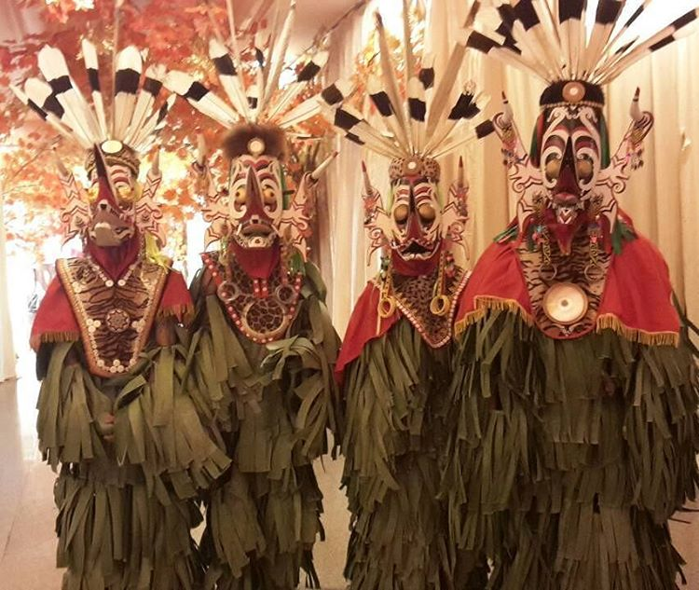

[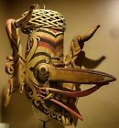](http://www.ebay.com/itm/GENUINE-DANCED-dayak-hudoq-mask-Indonesian-tribal-mask/141839366950?_trksid=p2054502.c100227.m3827&_trkparms=aid%3D111001%26algo%3DREC.SEED%26ao%3D1%26asc%3D20160908103841%26meid%3D2cc19dfb02df46da9fcde5b8f06debe8%26pid%3D100227%26rk%3D2%26rkt%3D14%26sd%3D141836684063)

[GENUINE DANCED dayak hudoq mask. Ind...](http://www.ebay.com/itm/GENUINE-DANCED-dayak-hudoq-mask-Indonesian-tribal-mask/141839366950?_trksid=p2054502.c100227.m3827&_trkparms=aid%3D111001%26algo%3DREC.SEED%26ao%3D1%26asc%3D20160908103841%26meid%3D2cc19dfb02df46da9fcde5b8f06debe8%26pid%3D100227%26rk%3D2%26rkt%3D14%26sd%3D141836684063)

$570.06

**Shipping address**

**Ralph J Coffman Jr**

149 Atlantic Ave

Swampscott MA 01907-2427

United States

**Order total**

|  |  |
| --- | --- |
| Subtotal | $570.06 |
| Shipping | $44.34 |